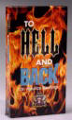
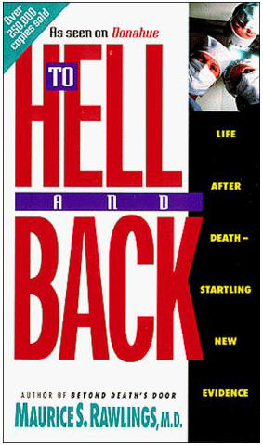
To Hell and Back
by Dr. Rawlings Documentary
Video Transcript, TBN Films

(Mathew 7:13-14)
Enter through the narrow gate, for the gate is wide and the way is broad that leads to destruction, and there are many who enter through it. For the Gate is small and the way is narrow that leads to life, and there are few that find it.
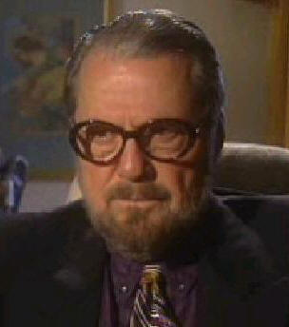 | [1st Witness]  There are people that talk about light, there are people that talk about floating above, there are people that talk about warmth and love, I didn’t feel any of that, I felt none of that. I felt untold terror.  It is very easy to be an atheist when you’re successful, but it’s very difficult to be an atheist when you’re laying on your death bed.

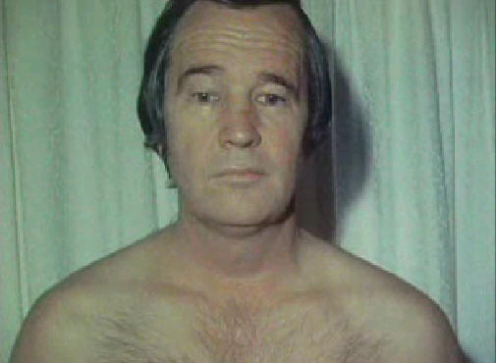 | [2nd Witness]  When I came to, Dr. Rawlings said my hair was literally standing on end.

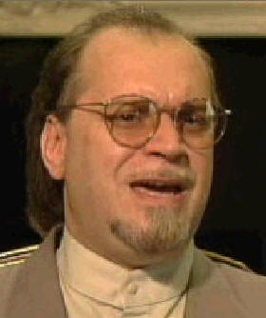 | [3rd Witness]  It was an incredible experience to see that there is life beyond life.
[Announcer]
Everyday people, like you and me, living their lives one minute and the next they lay dying, having never known or believed the message of salvation. They traveled from this world to one beyond, but what they found was pure terror. They returned and these are their true stories.
Renowned Cardiologist and Author, Dr. Maurice Rawlings will take you on a journey that few have ever spoken of.
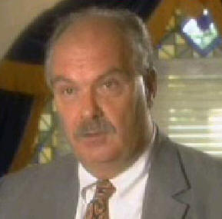 | [4th Witness]  So I called out into the darkness, “Jesus, please save me!” Because I was either going to Heaven or Hell, there wasn’t anything else.

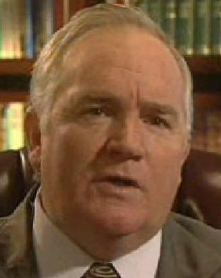 | [5th Witness]  Hear the voice of one that has heard the screams.
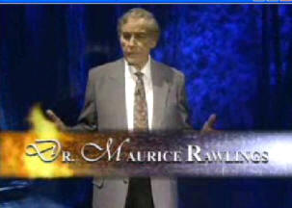
[Announcer]
This may be your only chance to safely go to Hell and Back.
[Dr. Rawlings]
This is a study on life after death. All through history man has predicted life after death. All bibles are based on life after death, all religions. But where are these? Who has come back to show us that there is life after death?
Now through modern resuscitation methods, bringing the heart back, bringing breathing back, we can now bring a whole population of people back to talk to us about what’s on the other side of death. See what you think about some of these cases that we are going to present. The good ones are a dime a dozen, because people love to tell about the wonderful experience they had after they died and came back.
The Hell experiences are somewhat embarrassing. It’s an F on the report card, a slap in the face from God. We have some cases of people who will tell you about their own hell experiences, so that you won’t have to go where they went. We mainly want to teach you how to restart the heart; restart the breathing, on someone who has recently died. Notice that death is reversible; you have 4 minutes of viable time before the brain cells start dying because of the lack of blood flow, and before rigor mortis sets in.
I have seen 2 deaths, where resurrection was required, something that man can NOT do. We can only do resuscitation, something God has permitted us to do. How many hell experiences have had a person's conversion and salvation while they were on the floor, and the person then only remember the good experiences? This was not the case in Ronald Reagan (Not associated with X-President Ronald Reagan) He had his little boy with him while going to a 7-11 store, he got into an argument, and there was a bottle broken, and he was stabbed multiple times by his assailant.
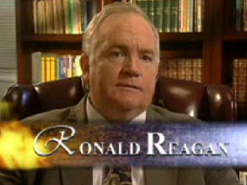
===Ronald Reagan ===
[Ronald Reagan]
In 1972 my life was broken. I was a drug addict. I was a criminal. My family was broken. My wife had filed for divorce a couple of times. My children were afraid of me. I really couldn’t hold a job, my mental state was terrible. It was in this frame of life that I took my 6 year old son to a little market to purchase some things. On the way in, I met a gentlemen coming out the door. An argument erupted and before I knew it I had hit him and knocked him down. He fell into a pile of bottles. Some bottles broke and immediately he leaped up with a broken bottle and began to stab at me. I lifted my left arm to try and stop the blows, and the bottle severed my biceps muscle & the major arteries in my arm. I was bleeding to death in a matter of seconds. But full of anger, hatred and rage, I kept fighting and it kept bleeding. My little son was screaming, he was hysterical.
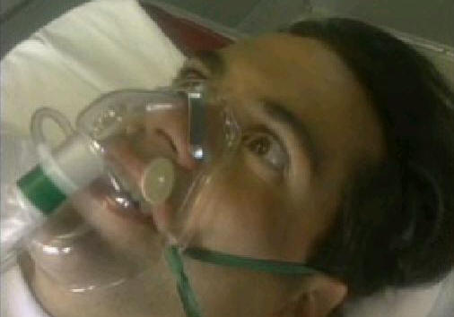
The owner of the 7-11 store came over and said that if I didn’t get to a hospital, I would bleed to death in just a few minutes. So he took me in my own car to the hospital. When we entered the emergency room, I was barely conscious. As the medical staff began to work on me, I could hear their voices, they were saying, “We can’t help him. He’ll have to be transported to another hospital. Probably we’ll loose the arm.” By the time they loaded me into the ambulance, my wife had arrived and went with us in the ambulance. But as they pulled out of the parking lot of that hospital, a young paramedic looked down into my face, and I could barely see I was so weak. He said “Sir, you need Jesus Christ” But I didn’t know Jesus, I didn’t know what he was talking about, so my reaction to that was to begin cursing. And again he stated to me, “You need Jesus!”
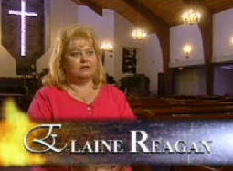

As he was talking to me, it appeared that the ambulance literally blew up in flames. I thought it had actually blown up. It filled with smoke and immediately I was moving through that smoke, as if through a tunnel. After some period of time, coming out of the smoke and out of the darkness I began to hear the voices of a multitude of people. They were screaming, groaning and crying. But as I was looking down, it appeared like a volcanic opening. I saw fire, smoke and people inside of this burning place. They were screaming and crying, they were burning, but they weren’t burning up, they weren’t being consumed. Then I began moving downward into this opening.
[Wife, Elaine Reagan]
He was thrashing, just thrashing about, moaning and groaning. It was like a battle was going on. I wasn’t a Christian at the time, and I didn’t know anything about spiritual battles. But it was scary to me because I could feel it. It was like light and darkness. It was like he was fighting against something. I didn’t know what, but now I know, he was seeing the vision of hell.
[Ronald Reagan]
But the terrible thing was that I began to recognize many of the people that were in these flames. It was like a camera lens was showing me their faces, close up. I could see their features, I could see their agony, pain and frustration. A number of them began to call my name, and said “Ronny, don’t come to this place, there is no way out. There is no escape if you come here, no way out.”
I looked into the face of one man who had died in a robbery attempt, he had been shot and bled to death on the sidewalk. I looked into the face of two others who had died drunk in an automobile accident. I looked into the face of others who had died of drug overdoses, that I once partied with. They showed agony and pain, but I believe that the most painful part was the utter loneliness. The depression was so heavy, that there was no hope, no escape, there was no way out of this place. The smell was like sulfur, like an electric welder, the stench was terrible.
In my life, I had seen people killed, I had been involved in fights where people were killed. I’ve done time in prison for manslaughter. I grew up in a reform school, and in a jail cell. I was beat unmercifully as a child by a father who had temper and alcohol problems. I was a runaway at 12 years old and I felt that there was nothing in this world that could frighten me. My life was wrecked, my marriage was wrecked, my health was wrecked. But now I was seeing something that scared me to death, because I didn't understand it. And as I am looking into this pit, this place of fire, screams and torment, I fade out into blackness.
When I opened my eyes, I was in a hospital room in Knoxville; Tennessee with my wife sitting by. There had been multiple stitches put into my body, my arm was spared. I had almost 100 stitches. I looked into the face of my wife. I wasn’t concerned about where I was, or anything around me. All I could visualize was what I had just seen.
[Elaine Reagan]
He had this funny look on his face, and it was a terrifying look. And he said, “I don’t really know what’s happening to me, but I’ve been in a terrible place.” And I kept telling him “you’ve been in the hospital, you’ve been in the hospital all this time.” And he kept saying, “No, I’ve been in another place. I don’t know exactly what is was, but it was a terrible, terrible place.”
[Ronald Reagan]
I could still hear the screams. I could still smell the terrible smell. I could still feel the heat, and I could still hear the voices of people that I’ve known screaming for me to go back. Through the days to come, I tried every way to get that out of my mind. I tried to get drunk, I could not get drunk. I tried to get stoned, I could not get stoned, I tried everything that I could to get this off my mind and I could not.
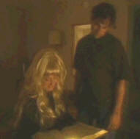
One morning, several months later, I came home to where my wife was. I had been trying to get drunk, but I couldn’t. When I walked in the house and went back to the bedroom, the light was on. My wife was sitting up in bed, and she had a large book open on her lap. She looked up at me and her face was literally shining. And she said, “Ronny, tonight I accepted the Lord Jesus Christ as my savior,"

She didn’t have to say a lot to me, our life had been filled with agony. She grew up in Chicago; her father was a bartender on the South side of Chicago. She knew nothing about God, or church or religion. The pain showed on her face, the wrinkles that I gave her from my abuse, violence, alcoholism, and drug addiction. Sometimes I would be gone for months of time, and she and the kids would have no idea where I was. But now her face had changed. The wrinkles were literally gone, a smile had replaced the sorrow and agony. She looked at me and said, “Jesus saved me tonight. Would you go with me and hear about this man called Jesus.” I thought to myself, “I tried everything else in life, nothing has worked for me. The people I love the most, my wife, my children, I’m terrible to them." So I agreed to go with her.
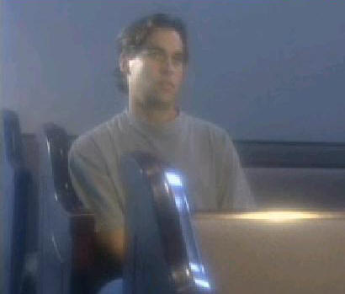
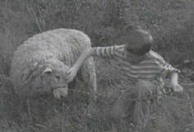
A couple of weeks later on a Sunday morning, November 2, 1972, just before 12 am, a minister stood to read from the bible. I was sitting in the back of the building, I didn’t know anything out of the bible. I didn’t know how to act at church. But the minister stood to read from the bible, and he read from the Gospel of John. He began to read these words “behold the lamb of God that takes away the sins of the world.” When he said “the Lamb” he had my attention. Any other passage wouldn’t have meant anything to me, but when he mentioned “the Lamb” he had this hard hearted sinner’s attention.
Because when I was 9 years old, a very poor child in the mountains of eastern Tennessee, with a father who only knew anger, abuse and alcohol, a neighbor had given me a baby lamb. And I had to walk two miles to catch the school bus. One day coming through her yard she stopped me and said, “Son I have a gift for you” and she showed me this baby lamb.
I took that lamb home with me, it was my friend, the only friend I felt like I had. It was such a friend, in the days and weeks to come it followed me, and it would meet me when I got off the school bus. It came walking through the woods and fields to meet me.
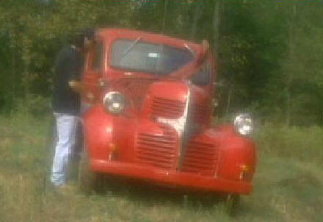
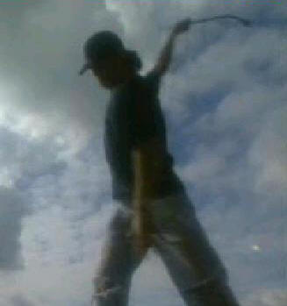
One evening as I came home, the lamb was missing. I heard my father cursing and screaming, he was working on an old model car, changing a flat tire by hand, the old way. I tried to walk around him because I didn’t want to be cursed. I tried to bypass him, but when I got on the other side of the car, I looked down and there was my lamb with blood all over the white wool. There was a tire rod sticking in its body.
The lamb had come around just wanting to be curious, and in a drunken fit of anger, my father had plunged the tire iron through that lamb.
When I saw my lamb, my friend, dead, I began to scream. I ran into the woods screaming, “he’s killed my lamb, he’s killed the lamb!”
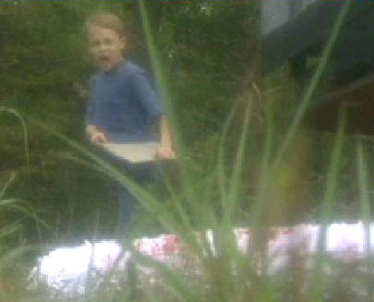
At 9 years old, hatred and violence took over my life, possessed my life. From that point on, I was never ever the same. By 12 years old I was a runaway. I was in the Juvenile system, arrested time after time. I had no respect for authority. I hated anyone that represented authority over me. By the time I was 15 years old, I had been in Jail for car theft, for stealing. At 15 years old I was sentenced for manslaughter; being involved in a car accident that had killed some and left others crippled. At that time I wondered if life would ever hold anything for me.
But when that minister mentioned “The Lamb” he had my attention. He said that Jesus Christ was God’s lamb, and He died and shed His blood so that whosoever wants to, can have a new start. They could be forgiven and start over.
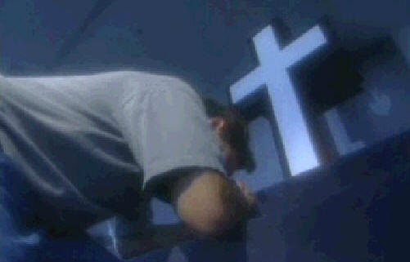
That morning, as I stood to try and leave the building, I thought, “I don’t want anybody to see me cry. I haven't cried since I was 9 years old. I’m not afraid of any living thing on this Earth, and no one is going to see me cry."
I turned to leave, but instead I started down the aisle toward the front of that building. I didn’t know the sinners prayer, I didn’t know the Roman road of salvation. But my prayer was this, “God, if You exist, and Jesus, if You are God’s lamb, please, please kill me or cure me. I don’t want to live anymore, I’m not a husband, I’m not a father, I’m no good.” And at that instant, it was like the darkness and the blackness left my life. Then the tears began to flow and for the first time since I was 9 years old, the tears did run. The guilt left my life, the violence, anger and the hatred left my life. And Jesus Christ became Lord and savior of my life that morning.
After that wonderful morning when I gave my life to Jesus Christ, I didn’t know what would happen. God healed my mind, my memory, the drug addiction; the alcoholism was instantaneously gone, delivered. And from that moment I knew I had to tell the story of what had happened to me. My life was only spared to tell others about the place that I had seen, and the hope of Jesus Christ to save mankind from this terrible fate.

=== OBE & NDE ===
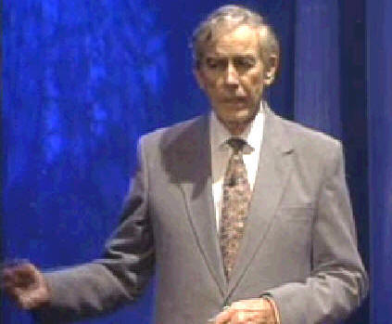
[Dr. Rawlings]
Here we are again wondering whether hell is for the bad guys or the good guys. I would like to introduce the subject OBE (Out of Body Experience) and NDE (Near Death Experience). You know what clinical death is, where the heart stops, breathing stops, but then we start life again. Restart the breathing and the Heart, and a person comes back from death to life. A reversible situation before rigor mortis sets in.
But Out of Body Experiences and Near Death Experiences are entirely different. Near Death Experience are like if I hold a gun up to you and say “give me your money.” You may get scared to death (a near death experience), but you don’t get anywhere near dying. Almost near car crash accidents, are near death experiences, but there is nothing involving stopping the heart beating or stopping breathing. And yet, most of the authors that write books on this subject are including OBE and NDE without clinical death. We are just investigating clinical death, where people actually die and come back to life.
Now Out of Body Experiences is a way to get there without dying. How would you like to find out what death feels like, without dying?
- Deep hypnosis can get you there.
- You can go see a guru over in India, learning meditation techniques with a mantra.
- You can have chemical hypnosis.
- You can go Skrying with a crystal ball.
- You can have electrical stimulus of the brain.
- [Please don’t get involved with any of theses.]
There are many ways of getting out of the body, to experience life beyond the body, separating the spirit from the body. This is the definition in the Bible, when the spirit separates from the body. But we are talking about a permanent separation, not a man-made separation. And we are not talking about NDEs or OBEs, we are talking about clinical death. This is where the great majority of people have true experiences.

=== Charles McKaig ===
One of the cases is Charles McKaig, a 57 year old mail carrier. He was having chest pains. We took him to the office; put him on the tread mill, until he got his chest pain again. He was attached to an EKG. (Electrocardiogram/heart monitor), the EKG went haywire. We knew he had chest pains, but before we could stop the machine, he dropped dead.
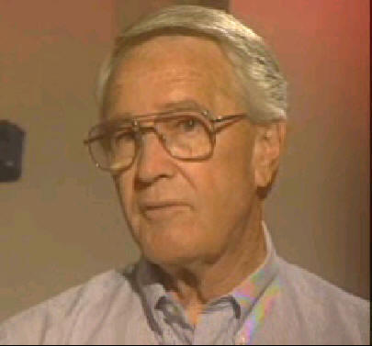
But when he dropped dead, he had a very peculiar situation. He convulsed like most people do when they first die and the heart stops providing blood to the brain. His eyes rolled up, he turned blue, he stopped breathing. The nurse started an IV and I started an external heart massage. The strangest thing happened, when I stopped resuscitating to put in a pace maker.
[Charles McKaig]
When I came to, Dr. Rawlings said my hair was literally standing on end, and my eyes had already started dilating. I was absolutely scared to death, I was horrified.
My life was very normal, I partied a lot. I had joined a church at a young age, because of my parents. I really didn’t realize what church was about, or what accepting Christ was about.
Early one morning at work I had walked to the local clinic in my hometown. At that time I thought I might be having a heart attack. So then I met Dr. Rawlings. He kept me for about 3 or 4 days. And then he gave me a stress test. I remember while taking it I felt like I really wanted to get off, and that was the last thing I remember of that.
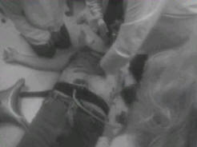
When I came to, Dr. Rawlings was giving me CPR, and he asked me what was the matter, because I was looking so scared. I told him that I had been to hell and I need help! He said to me, “keep your hell to yourself, I’m a doctor and I’m trying to save your life, you need a minister for that.” As he was giving me CPR, he was trying to install a pacemaker with the other hand. And I would fade out every so often, so then he would focus CPR again and bring me back.

I was soon floating in the air, watching what was going on, looking down. Whenever I would come back to my body, I kept asking, “Please help me, please help me, I don’t want to go back to hell.” Soon a nurse named Pam said, “He needs help, do something!” At that time, Dr. Rawlings told me to repeat this short prayer. “I believe Jesus Christ is the Son of God. Jesus, save my soul. Keep me alive. If I die, please keep me out of hell!”
After that, the other fading out experiences were very pleasant. I saw my stepmother, my mother. My mom passed away when I was about 5 months old. I never saw a photograph of her. My stepmother passed away about 10 years ago. I did not have any contact with them. All I could remember was that they kept their hands reached out to me.
I’ve heard it said that you couldn’t carry money with you, and when I was with my mother and stepmother, I saw they had no pockets. I know that sounds weird but I was trying to remember everything I saw.
After that, I remember walking down a lane that had colors on both sides, brilliant colors. I had a little experience in Art, but nobody, not ever Rembrandt could reproduce those colors, they were so bright. There was this light that surrounded me, I believe it was the Holy Spirit. It surrounded me and took care of me. I’ve never felt so good and so safe in my whole life.

[Dr. Rawlings]
After this was all over, I realized what really happened. It was a double conversion. Not only had this make-believe prayer converted this atheist on the floor, it had also converted this atheist doctor that was working on him. (Dr. Rawlings pointing toward himself) That is the only reason I can appear to you now, to tell you that there is a life after death. And it is NOT all good.
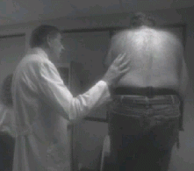
Most of you can tell the difference between simple fading, clinical death and biologic death. Take the case of Charles McKaig. He was on the treadmill and I could tell that he was in clinical death. He had a startled question on his face, he was about to ask the question and was looking dumbfounded at me. As he was walking on the treadmill I noticed that his heart had stopped and his breathing has stopped. He was still walking and talking for a minute or two before the lack of blood to the brain caused him to drop dead. He was dead and didn’t even know it. I should have told him.
Soon we started clinical death treatment, CPR. We started the heart up again, we started the breathing again and he came back. This was clearly clinical death. Now biologic death would have occurred if 4-6 minutes time had passed after clinical death. Because of the lack of oxygen to the brain, the brain cells die; they are the most sensitive cells in the body. Then rigor mortis sets in and the person becomes stiff as a board. And now we need resurrection, only God can do resurrection. We can only do resuscitation. Something we are permitted to do.

=== Howard Storm ===
Howard Storm was an art a literary professor who was in Paris with his class, when he suddenly had a stomach rupture, ulcer rupture, peritonitis, shock, sudden death, clinical death, resuscitation, and hell experience.
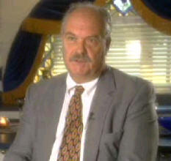
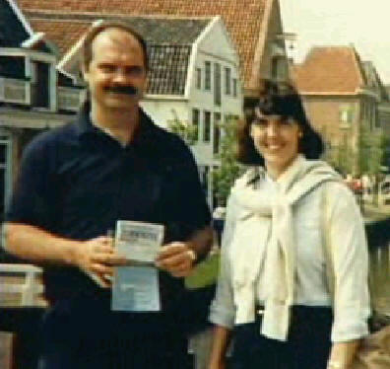
[Howard Storm]
I was a 38 year old college professor, teaching art. I had taken my students along with my wife around Europe. We had just done a 3 week tour, and this was the next to the last day. While we were in Paris, at 11:00 am, I had a perforation of my stomach. When this happened it was the most acute pain I had ever experienced in my life, and it just dropped me right down on the ground. So I was twisting, screaming, moaning, kicking and yelling around on the floor, and my wife called the emergency service.
A doctor came and got an ambulance because he knew what was wrong. The ambulance took me 8 miles across town to a public hospital. I was then taken into the emergency room and examined by 2 more doctors, who knew exactly what was wrong with me. Then I went into surgery.
But because there was no surgeon available, I was just parked there to wait. So I lay there for 8 to 10 hours in that hospital with no medication, no examination, no attention what-so-ever, waiting for a surgeon to come and give me a critical operation.
Now it 8:30 at night and a nurse came in and told me that they were very sorry that could not get a doctor for me and that they would get one the next day. When she said that, I knew it was over for me, I knew I was dead. The only thing keeping me alive was that I didn’t want to die. I knew I was an atheist, a non-believer, a person who lived for their own gratification.
Next to the pain, dying was the worst thing that could happen to me because it was the end of life, and there was no more, nothing else. But when she told me that no surgeon was available until the next day, the idea of trying to exist for another minute or another hour with this pain was not worth it anymore. I had been hanging on in the hopes that they would get a doctor and do the surgery, open me up and fix the problem. But when they said they could not get a doctor, I said to my wife that is was time for us to say good bye because I’m going to die now.
So she got up and put her arms around me, she told me how much she loved me and I told her how much I loved her, it was really sad. We made our good byes. We said those things you say after you’ve been together for 20 years.
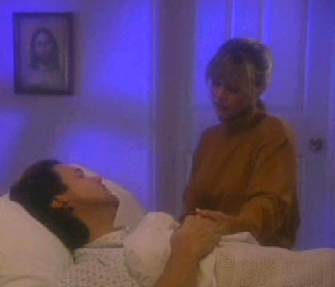
She finally sat down because she knew it was over, and I knew. It was so hard looking at her crying like that, so I closed my eyes and just let go. I went unconscious. I was probably unconscious for only a short while, a few minutes probably.
Then I was conscious again. I opened my eyes and looked and I was standing up next to my bed. I knew exactly where I was, and what the situation was, there was no confusion in my mind. I felt alive, more real than I’ve ever felt in my life. People asked me, “were you a ghost?” I was just the opposite, I was very alive.
As I am looking around the room, I notice that there is something underneath the sheet on the bed, a body. So I bent over the bed to look at the face and it looked like me. But that wasn’t possible, I’m alive, I’m great, I’m more than alive. So I tried to talk to my wife, but she couldn’t hear me or see me. I thought that she was just ignoring me. So I got very angry at her, for ignoring me.
So I’m screaming and yelling at her, “Why is there this body in bed that looks like me? How did it get there?” I had a sneaking suspicion that the body was me, but that was too scary to think about. So I’m getting really agitated and upset, because this is all too weird. This can’t be happening, it’s impossible; I got a hospital gown on, and everything is very real.
I hear people calling for me outside the room, speaking in soft gentle voices. “Howard, you need to come with us now. Come quickly, come out here.” So I went to the doorway of the room. There are people outside in the hallway. The hallway is dank, it’s grey, not light or dark, it’s just grey. All these men and women dressed in grey, in what might be considered hospital uniforms. I asked them if they were from the doctors to take me to the operation room. I told them all about my situation and how I have been waiting. They keep saying, “We know, we know, we understand. Howard come quickly, come with us, we’ve been waiting for you.”

I left the room which was really clear and bright, and I went into the hallway which was dank and hazy. I followed these people; we had a very long journey. There is no time, and when I make a reference to time, it’s just an illusion because there was no time in this place. But this place, if I was to recreate it, I would have to walk from Nashville to Louisville (175 miles, 281 km) to recreate the walk with these people.
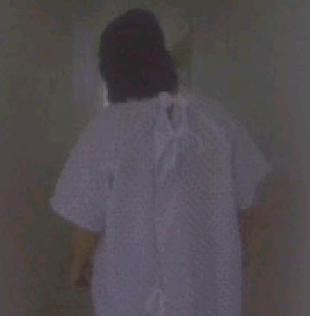
As we walked they stayed around me, kept moving me on, and it kept getting darker and darker. They were becoming more and more openly hostile to me. At first they were syrupy sweet to get me to go with them. Then when I was going with them they said things like, “hurry up, keep moving, shut-up, stop asking questions” It got more ugly.
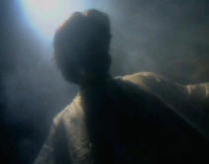
So we get into complete darkness and I’m absolutely terrified. These people are very hostile and I don’t know where I am. I said, “I’m not going with you any further.” They said, “You’re almost there.” We started to fight and I was trying to get away from them. They were pushing and pulling at me. There were now a lot of them. Originally it had been a handful, now with the darkness it could have been 100s or 1000s, I didn’t know.
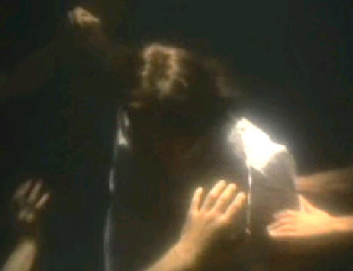
They were playing with me. They could have destroyed me if they wanted to, but they didn’t want to. They wanted to inflict pain on me, because they derived satisfaction out of the pain that I experienced. It’s really hard for me to talk about, and I won’t tell you much about it; it gets too ugly. Initially they were tearing with their fingernails, scratching, gouging, ripping, and biting. I was trying to defend myself, trying to fight them off and get away from them but it was like being in a bee hive, there were hundreds all over me.
Soon I was lying on the ground; all ripped up with pain everywhere, inside and outside. Even harder to bear the physical pain was the emotional pain, with utter degradation. I never once felt that it was unjust or wrong.
I heard my voice, not someone’s voice or the voice of God, it was my voice, but I didn’t speak it. Maybe it was my conscious, I don’t know, but I distinctly heard it say, “Pray to God!” So I thought to myself, “I don’t believe in God.” I was thinking, “even if I could pray, I don’t know how to pray anymore.”
At that time, I haven’t prayed for about 23 years. When I was a child, we said prayers in Sunday school and Church. I was trying to remember them. To me, praying was just reciting something that I learned.
“The Lord is my Shepherd, give us this day our daily bread, my country tis’ of thee. Wait, that’s not a prayer. Yea thou I walk through the valley of the shadow of death, for score and seven years ago our forefathers…” I’m getting all mixed up, I can’t remember how to pray.
Every time I would mention God to these people that hurt me, it was like throwing boiling water on them. They would shriek, scream and yell. They would use the worst profanity I had ever heard in this world. They could not bear to be around me talking about God. It was so painful for them to hear about God that they kept backing away. So I had a sense that I could push them away by talking about God. So I am trying to remember prayers, but I was getting confused and mixed up.
Eventually I realize that they are gone and I’m alone. I was alone there for an eternity, what I mean was that I had no sense of time. But I thought about my life, I though about what I had done, and what I hadn’t done. I thought about this situation I was in. The conclusion that I came to was this, my entire adult live was selfish, and my only god was myself. I realized that there was something terribly wrong with my life, and that the people that attacked me were the same kind of people that I was. They were not monsters, nor demons; they were people who had missed IT. The point of being alive in this world, they had missed it, they had lived lives of selfishness and cruelty. And now I was in a world where there was nothing else; nothing but selfishness and cruelty. They were doomed to inflict that upon each other and themselves forever, without end. And now I was a part of it.
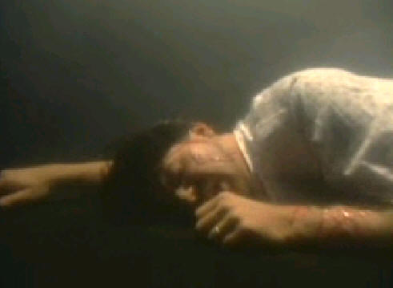
Though I didn’t want to be there, it seemed like the right place for me to be. I felt that this is what I deserver, because this is how I lived. You can’t imaging how emotionally painful that was. I’m lying there for time without end, thinking about my fate.
In the back of my mind comes up an image of myself as a child, sitting in a Sunday school class, singing Jesus Loves Me. “Jesus loves me, la la la, Jesus loves me, la la la.” I could hear myself as a child singing it. More important than anything else was that I could feel it in my heart.
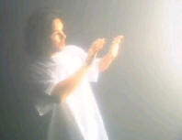
There was a time in my life when I was young and innocent and I believed in something good, I believed in someone other that myself. I believed in someone who was all good, all powerful, who really really cared about me, and I wanted that back. That which I had lost, I had thrown away, I betrayed, I wanted that back. I didn’t know Jesus, but I wanted to know Jesus. I didn’t know His love, but I wanted to know His love. I didn’t know if He was real, but I wanted Him to be real. There was a time in my life where I did believe in something, and I wanted to trust that it was true.
So I call up into the darkness, “Jesus, please save me!” and He came. First there was a tiny little spec of light in the darkness, vary rapidly it got brighter. The light became so bring that in the physical world it would have consumed me. It would have fried me to a crisp. But it was not hot or dangerous there. He was in this light and he reached down and gently started to pick me up.
In His light I could see that I was all gory, filthy and had wounds all over. I looked like road kill. He was gently putting His hands underneath me and tenderly picking me up. As He was touching me, all the wounds, pain and dirt just goes away. It just evaporated away, and I was whole and healed. And inside, just filled with His love. I wish I could explain it. It’s frustrating not being able to tell people about it because it was the best thing that ever happened to me in my life, it was everything. It was the ALL of life to know that love, and I just can't reveal that to you.
So He’s holding me, embracing me, rubbing my back, like a father would his son, like a mother would her daughter, just gently rubbing my back. I am balling like a baby out of happiness; from being lost and now found, being dead and now brought back to life. He’s carrying me out of there, and we just flew out.
We were moving towards a world of light, and I began to have thoughts of tremendous shame. I’ve been so bad, I thought of myself as dirt, garbage and filth. I thought to myself, “He’s made a mistake, I don’t belong here, He doesn’t want me.” How could He care about me, why me, I’m bad.
Then we stopped, we weren’t in hell, we weren’t in Heaven, we were in-between. He said, “We don’t make mistakes, you belong here.” We began to converse and He was telling me things.
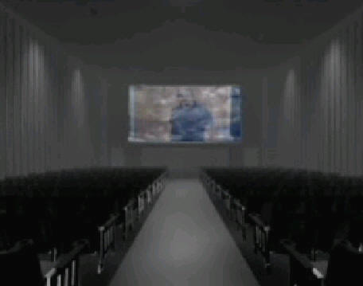
He brought over some angels who went over my life from beginning to end. They showed me what I had done right and what I had done wrong. And it was really simple. When I had been a loving kind person, considerate of other people, it had made the angels happy, it had made Jesus happy, and they let me know that it made God happy. When I had been selfish and manipulative it made the angels unhappy, it made Jesus unhappy, and they let me know it made God unhappy. What they were trying to convey to me, in a nutshell, was that my whole purpose of my existence was to love God and love my neighbor as myself. That is why I had been created, that is what I was in this world to do and to learn. But I failed.
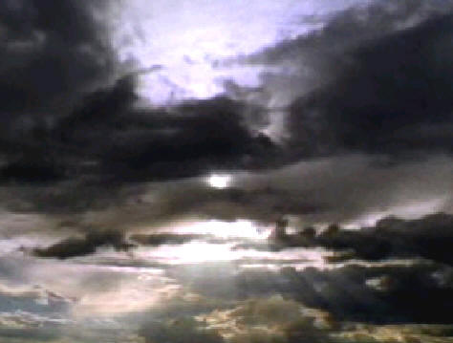
They told me that I needed to come back to this world, and I got really upset because I wanted to go to Heaven. What they told me about Heaven was that it was the most fun, most interesting, and most wonderful place. Everyone would want to go to Heaven and I wanted to get there. They said that I was NOT ready, that I wasn’t fit, it wasn’t my time to go to Heaven. It was my time to come back to this world and try and live the way that God wanted me to live, the way He created me to live.
I told Jesus and the angels that I couldn’t live in this world without them. I said that my heart would break if they sent me back to this world. They’d be there and I would be here. They said to me, “You don’t get it? What is the matter? We are showing you all this. We’ve always been there. We’ve been with you all this time. And you’ve never been alone down there.”
I said, “You’ve got to let me know that you are around once in a while.” So they said if I prayed and confess my sins to God, if I give what I had to God, meaning to give my worries, cares, hopes, and my dreams, just give it all up to God, then there would be times when I would know in my heart that they are there. Not necessarily seeing them, but I would feel the love like I felt then. I told them that if they will assure me that there are times when I can know that love, then I could live in this world. They said they would do that, then they send me back.
After the experience, the nurse who’d said that they couldn’t find a doctor, she ran back to the room and said that a doctor has arrived. at the hospital which is like this is pretty miraculous stuff because this is like around 9 or 9:30 at the night. She said “the doctor has arrived at the hospital and we are going to do surgery on you right away.” And some … people came in and they through my wife out of the room. It is very disturbing because I was trying to tell them I wanted to tell my wife what had happened to me. So when I pass my wife on the hall on the path to the surgery, I said everything is going to be great. And she just started thalling(?) …, that is like a dying man. Strange thing about this experience is the memory hasn’t dull at all. It is real tense and I don’t know it stays tense. I believe one of the reasons that God gives me this experience is that I would have the opportunity to share it with someone. I don’t know who and I never know who. But I would have the opportunity to share with somebody so it could be a help to them.

=== Street Interviews ===
(John 14:6)
I am the Way the Truth and the Life, no man comes to the Father but by Me.
[Announcer]
A random survey reveals that many people do not believe in a true Heaven and Hell. Many of those who do believe these places exists, have different ideas on how a person gets to one place or the other.
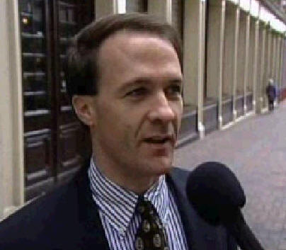 | [Random Person on Street #1 (Man)]  I don’t believe there is a Hell. I do believe there is a Heaven. Somehow there has to be more to this existence than just a short period of time on the Earth, there’s got to be something following it.

 | [Random Person on Street #2 (Man)]  I believe that everyone will pay for what they do in life. I don’t necessarily believe in what the Bible says about Hell being a fiery inferno, I believe Hell is just your worst fears and everything that can be evil in your own perception, you pay for - for eternity. And Heaven is just where you live the rest of your life in peace as long as you love God and live for God and live by His Word.

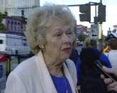 | [Random Person on Street #3 (Woman)]  I do believe there is a Heaven, definitely there is a Heaven. I’m not sure so much about the Hell. How do you explain Hell. However, Heaven Yes.

 | [Random Person on Street #4 (Man)]  I don’t think its necessary that you attend church to go to Heaven, or that you believe in the bible, but just live a good life. Hell is reserved for just a few really bad people, maybe somebody who might commit murder intentionally. Murder is probably the only thing that you would wind up in Hell for.

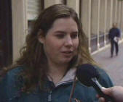 | [Random Person on Street #5 (Woman)]  I’m not really sure what would lead you to Hell, or why you would go to Heaven. I wouldn’t know.

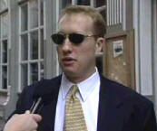 | [Random Person on Street #6 (Man)]  I think there is not really a Heaven or Hell, just an afterlife. I don't know exactly what it is. I not sure what there is, but I think there is some sort of middle, or limbo, or purgatory where everybody goes. Its neither really comfortable or really traumatic.

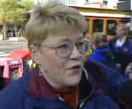 | [Random Person on Street #7 (Woman)]  I believe that everyone in their own mind thinks of a Heaven and a Hell. Heaven is what makes them happiest, what they are looking forward to in the future, and what they believe by “their own belief”, whether it be God or some other deity or entity, that Heaven does exist. And that is what they work for in life. My daughter is a proclaimed atheist, but somewhere in the back of her mind, she knows there is something that she wants out of the final life time. And to me that is all that is required, a deity is not required.

 | [Random Person on Street #8 (Woman)]  I believe in my own kind of belief which is more of a metaphysical belief. I believe however you feel on Earth, how you view Heaven, what it is, it’s your own conception. So it becomes that way when you die. So if you believe that there is a god source in you, and that you are a good person, and you’re a happy person, that is what happens to you after you die. But I don’t believe that you’re penalized, and you go to some place full of fire, because you didn't live your life the way organized religion thinks you should.
[End of Interviews]

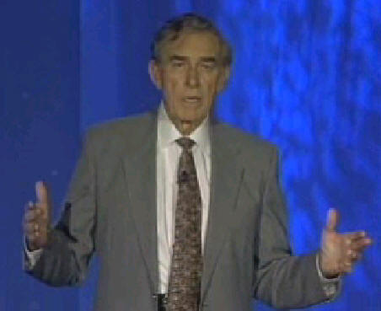
[Dr. Rawlings]
Many people are trying to dilute the message of hell and heaven saying that neither of these places exists. Why not eat, drink and be merry? If there is no accountability, then there is no sin. And if there is no sin, Christ died in vain. And if Christ died in vain, what do we need God for? This is the new philosophy of New Age, that there is no hell. It is a hope of most people that there is no hell.
Volunteers are going into hospitals, to visit our loved ones, with the New Age message. It is called the religion of the ending years, the religion of near death experiences. “Look, I went to heaven”, they tell the patient that is dying, “I saw the light and I came back. All is well. There is no accountability, there is no hell. Heaven’s gates are open wide for everyone who dies. Look at me. I am an atheist and I am here. You don’t have to worry. Death is nothing to be feared. I am going to stay with you. Your family is too afraid to stay with you while you are dying, but I'm not. Let me hold your hand. Let me tell you about this glorious thing that are coming to get you, this beautiful light at the end of the tunnel where there is no worry, no loss, only gain. You are acceptable as you are. There is no heaven, there is no hell. It is eternity for all." This is the new age philosophy called the Omega Faith, where everybody goes to heaven. There is a group of these people coming into our hospitals, consulting the dying, instead of our church groups consulting the dying.
Ministry to the dying is the most neglected ministry of all. Nobody wants it. Everybody is afraid of a dying patient. And the dying patient wants to know what dying is all about. Does it hurt? Is there a life after death? Is there a Heaven and a Hell? How can I make sure that I am going to get to heaven? And you can tell them it is a free gift. You can tell them how to get it. But if we don’t defend ourselves against the Omega faith, who are infiltrating the hospitals now with a faith that is deadly, then we are going to lose our own Christianity. The patient will die naked without any faith at all.

=== Dr. Donald Whitaker ===
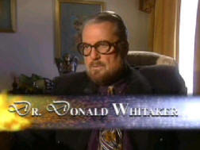
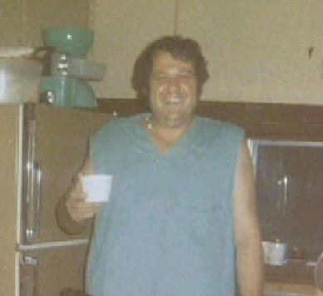
Our next case is of Dr. Whitaker who is still in practice, but was atheist at the time of the incident. He had nothing to do with God, but there was a situation that changed his life. We’d like you to experience it with him.
[Dr. Donald Whitaker]
It was February of 1975, at that time I was an alcoholic out of control. I was also using recreational drugs. But primarily, alcohol was my drug of choice. I was totally out of control. I had a lot of friends in the entertainment business; Ringo Star and a bunch of other people.
They were having a TV special on the west coast. Hoight (a friend) had called me and asked me if I would like to go. I told him that I would love to, because I knew there was going to be a lot of booze, and partying. While they were doing their special, I was doing my thing.
After about three or four days out there, I became ill. I had severe pain in my abdomen. I flew into Oklahoma city, called a senator friend of mine, and asked him to send a car for me because I was sick. They sent a car and took me home. And I checked into Whatley hospital in Texarkana, Texax in February of 1975. I checked in with electrolytes, which means that the chemicals in my body were so far out of balance that they had to give me IVs to build me up.
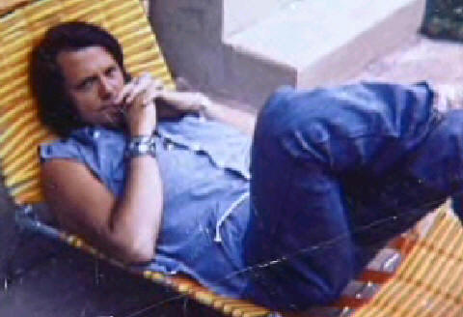
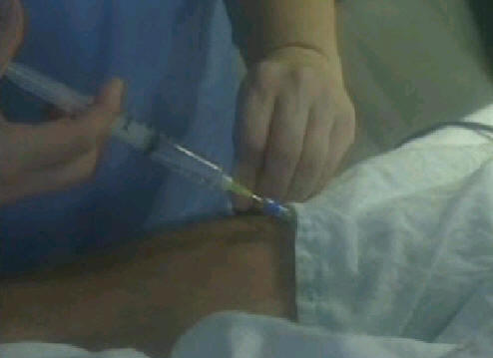
At that time of my life, I was atheist. I was hard core atheist and was living for myself. Atheists are self centered, they live for themselves. This is where I found myself in 1975 in my hospital.
After 3 days they operated me. Later, I found myself in the intensive care on a respirator, which means it was breathing for me. I couldn’t speak. I’ve been there in a comma. I heard these people talking about how sick I was and how I was going to die and how I wouldn’t get out of the hospital. At that time my hair was very long because I just wore my hair long. And I heard one guy say, “My, his hair is long.” And another guy said, “Not nearly as long as it is going be before he gets out of here.” And the third voice said, “He's not going to get out of here. He's going to die.”
And after 3 days, I could breath on my own. I remember my doctor, my surgeon, Dr. Donald Dunkon said to me, “Don, if you have anything to get right, if you have anything to get signed, you get it done because we are not sure how long you have.”
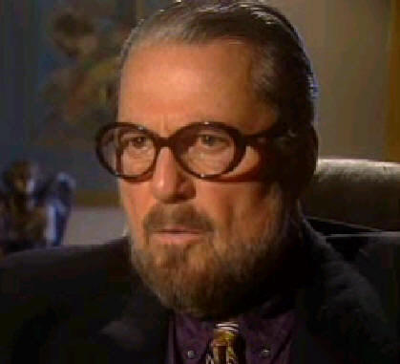
I knew I had a condition which is that was called Acute hemorrhagic narcotic pancreatitis. You don’t live with this disease. You could live with pancreatitis. You could even live with Acute pancreatitis, but you do not live with Acute hemorrhagic narcotic pancreatitis. Dunkon had told my two sons that I would be dead before morning. They didn’t expect me to survive.
I was laying there, a professed atheist. I didn’t believe in God. I believed in the power of the universe because I’ve seen it. As a physician, I’ve dealt with life and death. I believed in something, but don’t talk me about God. And surely don’t talk to me about resurrection, virgin birth or these type of things because I am in research and science. The Majority of PHDs in research and science don’t believe in God. They do not believe a supreme being. They are beginning to believe there is an order in the universe because the further along we go, we see the order.
It is very easy to be an atheist when you are successful. You have worked your way from Oklahoma welfare to be one of the most powerful men in your part of the country – one of the most powerful men in the state of Oklahoma, politically. It is very easy to be an atheist when you have done all of that. A man could sit back and say "I don’t need God. What is God?"
But it is very difficult to be an atheist when you are lying on the death bed, because you began thinking "what if these people are right?" There had been one man named Ron Short, that stood between me and the gates of hell. One man had witnessed to me about the love of Jesus for 5 years, before I became ill. I would debate him and I liked him, because he did what he said he was going to do. He was the only one that I saw that profess to be Christian and lived what he said he was going to do. I really respected him. I didn’t believe what he said but I respected him.
When I was lying on my death bed and knowing that I was going to die, guess who I thought about? I thought, "what if Ron is right? What if there is a Heaven and a Hell." Almost immediately the most pressing thought in my mind is how do I get saved. What is saved? How do I get saved?
So I sent people out to get Ron Short. I wanted him to come down because I wanted him to do whatever he had to do. I had no idea how a man hanging on a tree in Israel 2000 years ago could save me. What is that to me? But I knew he had something that I had to have. That night Ron wasn’t home, he was in Alabama. So I had people go and get Ron.
That night was the longest night that I’ve had in my entire life, before or since. As I am laying there in bed, I had begun to fade away into darkness. It was so, so dark. It was like the darkness just penetrated into your very being. I can tell you that I left my body because I remember coming back into my body. I don’t know where I was out of my body.
There are people that talk about a light, or floating above, a feeling of warmth or love. I didn’t feel any of that. I felt none of that. I felt untold terror, untold terror. I knew that if I went all the way, if I slipped all the way, I would never get back. In my being of beings I knew that. So I fought all night long.
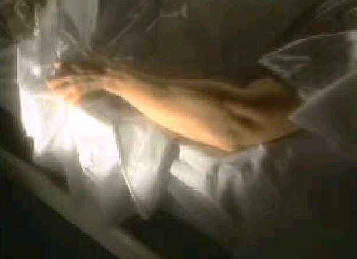
They told me later on that I not only pull the mattress cover off the mattress, I put the mattress upon me. I had to stay, I had to wait till Ron got there. Whatever he had to do, I had to wait.

But again when I would leave my body, I would be going down into deep dark terror. My skin began to get cold. Not the kind of cold you feel when you walk out in the air, no, this was bone chilling cold. And I could feel the coldness began to come up my legs.
Again I would begin to leave my body and would be in the darkness, in that void. I remember one time entering back my body, I felt my body thud, my physical body thud. Believe me, believe me, that was the most horrifying terrifying experience that I had ever encountered.
I fought all night long. The next morning around 9:30 or 10 o’clock, Ron came in. He said, “Dr. Whitaker, what do they say are your chances?” I said, “Ron, they tell me I have none.” He said, “Now is the time.” I said, “You're right.”
Before, I had cursed him, I had spit on him, but now it was the time because I had to have whatever he had. I had a short period of time left on earth and I didn’t have any idea when I might make that trip and go all the way.
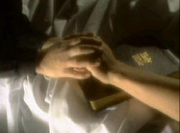
At that time Ron simply led me in a sinner’s pray. I had no idea what a sinner’s prayer was, but I trusted Ron. He led me through the sinner’s prayer and told me that Jesus had died for my sins. He had died for the sins of the world. I didn’t quite understand that. He showed me in the word of God where that was written.
You have to understand that I am a man of books. I’ve spent big part of my life, 25 or 26 years of life in books, all types of scientific books. I have degrees in Chemistry, all the way up to medicine doctor to practical medicine.
He told me and I believed him because it said so in this book. It was a new book to me, it was called Bible. I had Ron lead me, and I said the sinner’s prayer. I can tell you one thing, there was a peace that came over me like I have never known.

I’ve searched for that peace in the bottles, alcohol, needles, drugs, and women. I’ve searched for it in all type of places. But there was no peace in my life. But once I accepted Jesus Christ as my Lord and savior, I was no longer afraid. I still believed I was going to die because I knew the condition I had, and you don’t survive it. I knew that, I am a physician. I knew what I had you did not survive.
Ron showed me in the word of God where it says, “These signs shall follow those that believe. They shall lay hands on the sick and they shall recover.” (Mark 16:18) I walk around on planet earth this day, taking no insulin, taking no enzymes, eating whatsoever I want, and everyday God produces in my body the correct material for me to function without having to take medication.
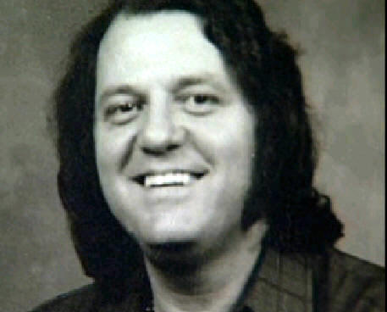
When you see blind eyes open, you see the cripples walk, you see the leprosy cleansed, and you see them with your own eyes, then it doesn’t take a rocket science to figure out that Bible is true.

=== Dr. George Rodonaia ===
[Dr. Rawlings]
How can the various stages of Hell have different aspects to people? The Bible doesn’t say it is all fire. If you look at different places, it says
- “cast out”
- “separate from God”
- “total darkness”
- “with worms that cannot die”
Most of it is flame. Seeing the angels of light can be deceptive in some cases. For instance, 2 Corinthians 11:14, it tells us that even Satan can change himself into the angel of light and deceive many. Which light did these people see at the end of the tunnel, especially if it was someone that didn’t think they deserve to be in Heaven? Those things do occur.
Strangely enough the opposite does not occur. Those that saw themselves in Hell knew exactly where they belong. And there was no question why they were put there. In fact, Christ talked about this Himself in Mathew 25. Jesus also said that if Satan cast out Satan, how would his kingdom stand? (Mathew 12:26) Meaning, why would Satan show people that there is a Hell, that would work against his kingdom and his lies. No, impossible. As an angel of light, Satan can deceive many. But this variation that they see in Hell, whether it is total darkness or whether it is fire, both are places where they never want to visit again.
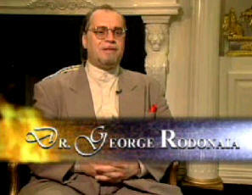
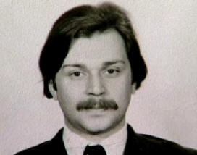
This brings us to the case of Dr. George Rodonaia, a young Russian fellow, very intelligent. He came with a Ph.D and an M.D, but had trouble with KGB. He couldn’t get out of Russia. In fact when he tried to get out of Russia, he was purposely run down by a KGB agent, who drove on the sidewalk in order to run him over. This is how he died and where his story begins.
[Dr. George Rodonaia]
As a psychiatrist and a neuropathologist, for me God never existed. I never believed in God. I never believed in the Bible. I never thought about God, the Bible or divinity. In 1976, I was 20 years old, I was already a doctor working in Georgia, Russia.
I met a lady from Texas. I tried to leave the country many times. But I didn’t have much help. This lady tried to help me and I got in big trouble with the KGB. I worked on “idenotintriphosper”, it is a neuron transmitter in our brain. With the conjunction of "Oxitocin", I discovered several things.
I was an important scientist and KGB didn’t want me to go so they decided to kill me. That is how I got into another dimension of my life.
I was standing on the sidewalk, ready to depart to NY, waiting for cab, when a car on the sidewalk hit me. I flew in the air 10 meters, and then the car ran over me. My friends and relative took me to the hospital. The hospital staff, friends of mine and 2 other professors declared me dead. On Friday night, they put me in the morgue, in the freezer.
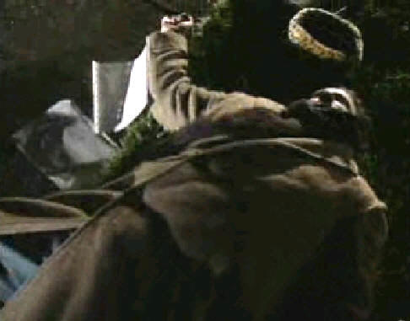
Three days later, they took me out. So on Monday morning they began my autopsy. These 3 days of being out of my body, seeing everything that was happening around, seeing myself, my body, seeing my birth, my parents, my wife, my child, and my friends. I saw their thoughts. I saw what they were thinking, how their thoughts move from one dimension to another.
It was incredible experience. I was in darkness, total darkness. The darkness was pressing. This darkness existed not beyond, but it existed within. What I want say is that the darkness was pressing. And I was in the middle of this fear and I did not understand why and how this darkness existed. Where was I?.
I understood that I didn’t have a body because I didn’t feel it. Then I saw a light. I went through a little hole into that light. But the light was so powerful, so burning. You cannot compare it to anything. No words can explain it. The light was so burning, going through flesh. I didn’t have a body. That was the most interesting part.
And I was scared of the light, I wanted to go into the shade to save myself from this light. What is that light? I don’t know. It can be called the light of God, it can be called the light of Life. But light is light and darkness is darkness. As a psychiatrist and scientist, I did not think about that. The only thing was that I was in light.
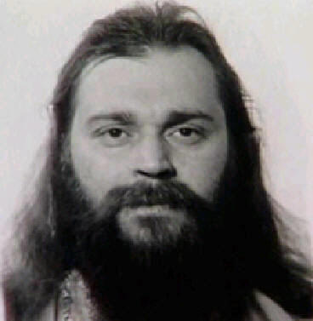
We were not raised in God’s way. You know about the Soviet Union, we didn’t go to church. There were people who went. But they were some kind of limited people. We thought they didn’t know any better that there was no God. But those 3 days of being in the morgue, the freezer, changed all my life.
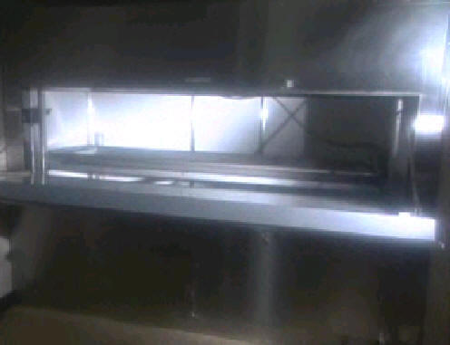
They begin the autopsy, and started to cut open my chest. That was the first incision, then I opened my eyes, and they saw that my pupils were convulsing, getting smaller. When they saw that my eyes were reacting to light they knew I was alive. They put me back to the hospital and began resuscitation.
My lungs were collapsed for a long time so I was put on a respirator for 90 days. My recover did not happened fast, but the life did came back. They discovered was that the life was there during the autopsy, but not all my organs were working. It was hard work for nine month being in recovery, it didn’t happen immediately, but the life was there. But the doctors had to help me survive and help me to regenerate my health and organs.
When I came back to life, a lot of different experiences had happened. I experienced a lot of rejection, a lot of fighting with others. But nothing could change my mind, I knew my destination, I knew my way. I decided to leave the country, and this lady from Longview Texas helped me move to the United States. We went to Texas and continue to live there today.
Sometimes things are beyond our grasps. But I don’t try to explain it all because I know and I believe that God knows better. I believe that I don’t need to explain everything. But why it was shown to me and why was I chosen? It was a question that I honestly didn’t care about. I care that I deeply believe in a God of love and God is love. And I believe God created everything for betterness and for an incredible future if we don’t ruin it.

=== CPR Instructions ===
Full instructions at http://globalcrisis.info/cpr.html
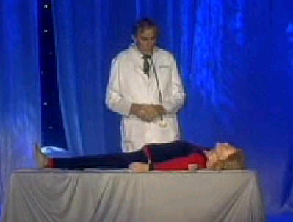
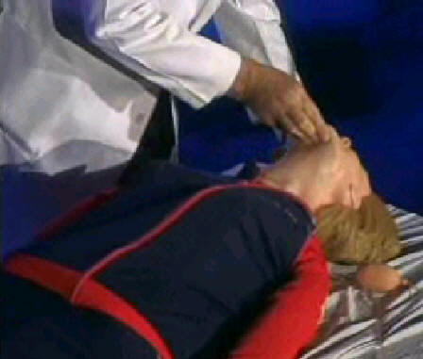
[Dr. Rawlings]
And now I want to show you CPR. We said we’d show you how to start somebody’s heart up again and to start their breathing up again. You do it with your bare hands. So first you see if the person is alright. Maybe she is intoxicated. Will she will talk to you? Maybe she just bumped her head. You immediately look, feel and listen if she is breathing. Is the chest is moving, nostrils moving? Is any air exchanges felt? If not, immediately goto the airway, forget the heart, only work on that after the airway.
You unobstructed the airway by lifting the chin, pointing to the ceiling. This straightens out the windpipe. Then you close her nostrils so your air in her mouth will inflate her lungs. You give her 2 quick breaths. And see if her diaphragm rises. And if it rises, it is an unobstructed airway. But if it is still obstructed, you go back to give 2 more breaths and reach down into here mouth to unobstructed the airway. If her heart is not breathing, you determine that by not listening with your ear but feeling on the carotid artery pulse on either side of the Adam’s apples, bom, bom, bom.
If you do not feel that, then after the 2 quick breaths, 2 inches above the xiphoid, either part of the breastbone, diaphragm, lower part of the breast bone, you plant the heal of one hand, supplemented with the heel of the other. Push your weight down on her.
This is the critical moment in life. If you can catch people before they die and give them the option of accepting Jesus Christ as their personal savior, then they can’t loose whether they live or die. That is with them forever. And when they die like this, we don’t have to question where they went. And the preacher will be right when he says they are in Heaven. She went to heaven to be with God.
But for those who die on the street, where do they go? It is the minister’s fault, your fault and mine because we did not approach them with the Gospel which is the free gift to anyone that wants it.

=== Conclusion ===
All of these Hell experiences had one thing in common. Surprise! They didn’t know there was such a place. Will you find it as surprise? Will I find it as surprise? Or will we be prepared? Hell is nothing new. It has always been there. These people just discovered that when they died and came back. They want to tell you about it.
[Dr. Rodonaia]
And I experienced what is love, what is faith, what is hope. And all these 3 are wisdom of God.
[Dr. Whitaker]
The prayer of faith, the prayer of salvation, is not some little prayer, is the only way to the Father. And that is the only way. Now all of these people in the New Age movement that believe that everybody is going to heaven, that you can worship anything, you can worship a flee, you can squeeze a tree, you can worship a crystal, you can worship a star. I got news for them, they are not going unless they accept Jesus Christ as their Lord and Savior, because the word says the only way to the Father is through the Son.
[Ronal Reagan]
Don’t go to hell. Please. I beg you. Don’t go to hell. It was not prepared for you.
[Charles McKay]
If you are saved, you are saved, if you have accepted Jesus.
[Howard Storm]
Do not put it off for tomorrow, for any reason, because you might die this very moment.
[Charles McKay]
It is the best thing that ever happened in my life.
[Howard Storm]
You can feel Jesus’ presence with you, today, in this place in this time.
[Ronal Reagan]
It is not God’s will that any people should perish. I didn’t know this. I didn’t know the love of God. All I knew was hatred, violence, and abuse. But there is one that cares. His name is Jesus.
[Whitaker]
And who is the Son? He is the word made flesh and came and dwell amongst men. The word is the way to the Father.
[Howard Storm]
Make a choice. Not tomorrow, not tonight. Make a choice right now. Are you going to give your heart over to Jesus or not?
[Charles McKay]
If you want to have a life after this one, you better accept Jesus.
(Revelations 3:20)
Behold, I stand at the door and knock; if anyone hears My voice and opens the door, I will come in to him and will dine with him, and he with Me.
[Dr. Rawlings]
Friends, you’ve heard the evidence. This is the closest you are going to get to making a decision. Is there a life after death? Are these people that were presented to you turning their whole lives upside down for nothing, or because there IS a heaven and a hell?
Have you made the decision in your own life? Do you know if you died tonight that you will be with God in Heaven tomorrow? And remember the quote from Revelations 3:20, Behold I stand at the door and knock. God is knocking right now. If you hear me, open the door and I will come in. I WILL come in, not might come in, and fellowship with you and you with me. It means you come dirty, just like you are. He will fellowship with you and tell you how to clean up your life. And meanwhile in exchange, give you this free gift of eternal life with Jesus Christ because you are one of His. You are now a Christian.
(John 11:25-26)
I am the resurrection and the life; he who believes in Me shall live even if he dies, and everyone who lives and believes in Me shall never die. Do you believe this?
the End
To Hell and Back
by Dr. Rawlings Documentary

