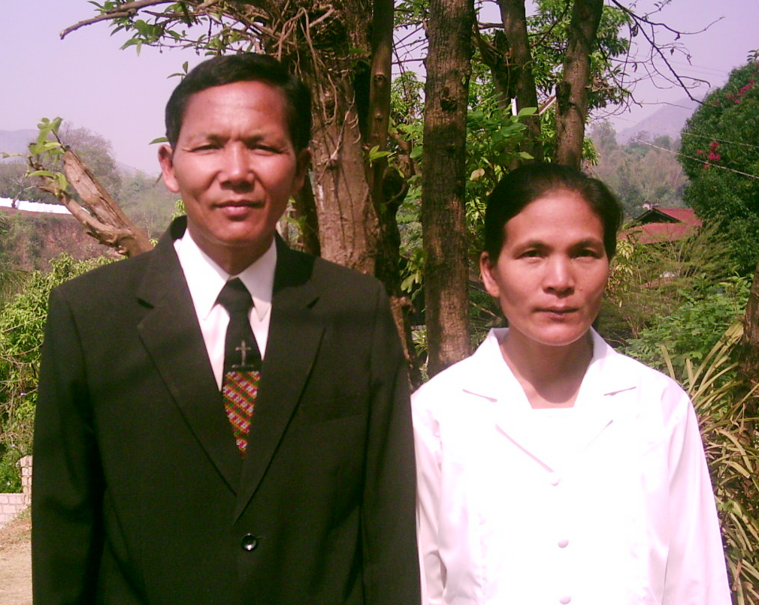
The Testimony of Rev Yong Thang

Do you know what a man experience when he is dying?
What will he see immediately after his death?
After that, where will his soul be ?
He experienced death, who had been to hell and heaven and resurrected.
Rev Yong Thang and wife

Introduction
My name is Yong Thang and I am from Myanmar (Burma). I belong to the Chin tribe. This tribe is one of Myanmar’s Nationals. I came from a poor traditional peasant family. I was born on 3 April 1958. I grew up in a small village in the Chin State.

Life and background
Because of my family’s financial difficulties, I left school when I was studying at ninth standard. Then I started working with my parents. At that time, my family members were just traditional Christians. They did not know where they would be going after death. When one of my friends asked me,” Yong Thang, where do you think you will be going after death?” I could not answer him. I was not sure of myself whether my soul would go to heaven or to hell when I die.
To me, heaven seemed to be a fairy tale. It was hard to understand and difficult to accept. I did not know what it means to accept Jesus Christ as my Savior.
During the spring season in 1980, there was a Bible seminar being held in our village. I attended the seminar from the beginning to the end. From that seminar, I became aware of the salvation in Jesus Christ. There was revival in the whole village. I accepted Jesus Christ as my personal Savior with all my heart since then.
During the Day of Pentecost in 1980, all the villagers went up to the mountain to fast and pray for three days. On the last day of fasting and prayer, I experienced the power of the Holy Spirit and I felt my whole body being “warmed up”. I experienced unspeakable peace, rest and joy in my heart. I knew beyond the shadow of doubt that I was a new creation and had eternal life. By fasting and prayer, I received the assurance of salvation in Christ. I had full confidence that I would be in heaven when I die.

Serious illness and death
Not long after I had got married, my wife and I moved to Thayar Gong village in Kalay, which is a part of Sagai province in Myanmar and we were working in the farm. A few years later in early August 1984, I became critically ill. I was bedridden for several days and could not eat. Although my wife took care of me as best as she could, my condition became worse. Realizing that I might not live long, she quickly informed my family members, relatives and friends to visit and see me for the last time. They came and visited me as soon as they heard about my condition. On 13 August, about 7pm, I gradually felt in my body that my blood circulation was not normal. It was Sunday and all my family members, relatives and friends had gone to church for evening worship service except my wife. My wife was then falling asleep as she was physically exhausted.
I experienced tremendous physical change in my body step by step. I was very anxious and I thought, “Oh! Today is my last day. I am about to die soon.” I intended to wake my wife up to say my last words to her but I changed my mind as I did not want her to feel sad. My toes started to feel cold. Soon, my legs, fingers and my whole body were gradually turning cold.
I tried to move but could not. In my mind, I said to myself,” Look! My body has become immobile. I cannot move my eyes. My mouth is tightly closed. It cannot be opened!” Then, I sensed that this was not ordinary cold. These were the signs of dying. I could not resist death.
However, I knew where I would be going. I would be in heaven! Looking at my wife, I took pity on her as she would be alone for the rest of her life. So I prayed to God to take care of her for her entire life. I committed my life in God’s hands in the name of Jesus.
After a while, I saw cluster of dark clouds descending from the sky. (Though there was a roof on top of me, I could actually see the sky through it.) The dark clouds were approaching me. They landed and stopped above my bed about three feet away. At that very moment, my soul left my body.

Going to heaven and hell
I looked down and saw my body lying beside my wife. It was completely a lifeless corpse! I was well aware that my body had died. Suddenly, I saw large demons coming from all directions. They gathered around my bed and stared at my body. I then looked towards the sky and shouted, “Angels! Please protect my body immediately.” Thank God that although I had never known how angels looked like, they appeared when I shouted. Five angels came down immediately from heaven to guard my body. At the same time, the demons, which gathered around my body, disappeared instantly I suddenly remembered what was mentioned in the Bible ‘Are they not all ministering spirits sent forth to minister to those who will inherit salvation’ (Hebrews 1:14).
After that, I looked what was ahead of me. I saw a place burning with large flames of fire. It was horrified. From the fire, I heard thousands of lost souls crying out, “Please save us! This place is too much for us to bear and we are in great pain and suffering.” When I saw them, my heart was overwhelmed with sorrow. Suddenly, I heard a voice from heaven saying, “This is hell!” I had read about the existence of hell in the Bible. I now saw the place ‘hell’ with my very own eyes and it was real. I wondered why these souls were suffering in such a terrible place. The lord knew my heart and said, “When they were alive in the world, they did not accept me as their Lord. After they passed away, they were immediately brought to this place.” Then I saw a big black hole. It was very deep and filled with powerful unquenchable flames. It looked very frightening. A voice spoke to me, “This is the bottomless pit where the devil will be bound one day.” When I looked down at the world from a high altitude, I saw people going and coming forth, working and sleeping, eating and spending but they were never content in their lives. This led to frustration and ended with miseries and sufferings. The world is really not a good place to live. I felt deeply grieved in my heart for the suffering world and uncontrollable tears were rolling down my cheeks.
I then saw angels flying up and down from the heaven to the world praising God. Next, I saw a strong beam of light from heaven. An angel took me into heaven. When I entered heaven, surprisingly I saw thousands of saints. They wore white robes and were singing, “Hallelujah! Amen! Praise the Lord!” They welcomed me warmly for my arrival to heaven. It really touched me. When I was in the world, no one respected or paid attention to me because I was just an ordinary farmer.
The scripture recorded that “Likewise, I say to you, there is joy in the presence of the angels of God over one sinner who repents.” (Luke 15:10). It was absolutely true. I was filled with complete joy. Every one in heaven was joyful. I then realized that there was no sadness, pain, distress, hunger or fatigue in heaven. Heaven was a place filled with the glory of God.
One can live generally about 70 to 80 years in this world. No one can decide how long he wants to live. It is a very short period of time in the sight of God. The most important thing in a person’s life is to know where his soul will be going to after death. People are working hard for their lives for selfish gain but eventually this will lead to emptiness. They are not concerned about the need to accept Jesus Christ as their Lord and Savior. At the end of their lives, their souls will be tormented in hell eternally without Jesus.
Heaven is full of joy and peace and it is definitely good place to live in. No words can be used to describe how wonderful heaven is. When I looked around in heaven, there are no sun, stars and moon but every place is shining with the light of God. The place was not hot. I felt my body and spirit both being strengthened by the light of God. Although my parents, my wife and siblings were still alive in the world, I did not wish to go back to the world because I had been separated from the painful and suffering world. It was difficult for me to express in words how a man feels in the realm of happiness.
The Lord Jesus Christ suddenly appeared and gave me a gift box. I bowed down before the Lord to receive it. When I looked up, he had already disappeared. Then an angel took me to a place whereby I could see my reflection on the road.
The Bible mentioned that the road in heaven is made of gold. I saw with my own eyes that it was true. The Bible still remains valid and relevant though it was written thousand of years ago. It records and writes about creation; hell; past, present and future events. It reveals to people that salvation is found in Jesus. It is not the idea of any great man or philosopher. Every word in the Bible is true. Jesus said,” I am the way, the truth, and the life. No one comes to the Father except through Me.”
Dear friends, God repatriated me from heaven because He wanted me to share with you what I had seen in heaven and hell. Heaven and hell do exist. May God judge me if I had lied or deceived you in any way!
It is the desire of God for everyone to believe in Jesus Christ so as to receive salvation. He does not want anyone to spend eternity in the lake of fire. Therefore, I urge you again to carefully take heed of this testimony.
When I was walking on the golden road in heaven, I saw a bright house made of beautiful jewels. No house in this world can be compared with it. I was captivated by what I saw. Just then, I heard the voice of Jesus saying, “This house is for you, I will let you live here forever.” Oh, I was excited! It is my eternal home!
Then I rushed towards the house and searched for the entrance door to get in. But Jesus said, “No, Yong Thang. It is not your time yet. There are still many people out there who have not accepted me. You must go and warn those who are not saved so that they will not end up in the lake of fire. The day for Me to come to the world is drawing near. I will come real soon. I hope the hearts of many people will be changed by then and they will accept me through your testimony.” Although I was very reluctant to return to the world, I could not disobey Him.

Returning to the world
Eventually, an angel brought me back from my beautiful house to the world. Then I entered again into the corpse which had been laying cold for hours. After I had entered my body, the angel woke my wife up by pushing her hand. She got up and Lit on the candle to look at me. My body was still cold because I had been dead for ten hours. She thought that I had passed away and started crying loudly. As a result, everybody at home and my neighbors rushed in and stood around me. Some were sobbing. I felt great sorrow and started weeping. Then my body gradually became warm. They realized that I was still alive and were comforted. My wife delightfully came over to attend to me. She fed me with some food and water. It was about 5:00 am and the sky was already bright. I had died for 10 hours from 7:00 pm to the next morning 5: 00 am. I could not forget the horror of hell and the beauty of heaven which I had seen. It was not a dream or illusion. Although that incident happened 20 years ago, it was still vivid in my mind as if it just happened yesterday.
Therefore, I write this testimony in order to share with the whole world that people may know Jesus Christ and accept Him as their personal Savior and Lord.
After recuperating, my wife and I went to share the gospel from one place to another. We also studied in a Bible school so as to learn more about God’s word.

Note: Pastor Yong Thang had graduated from Bible seminary and at present serving full time for the kingdom of God as a pastor, preacher, minister and evangelist in the Northern Shan state of Myanmar.
Dear brothers, sisters and ministers, after reading this testimony, do contact our ministry should you have any questions or want to see Pastor Yong Thang personally. We appreciate your contribution or involvement in spreading the word of God.
We pray that everyone who reads this testimony will accept Jesus Christ as their personal Savior and Lord.
Myanmar Gospel Testimony Ministry
mgtm777@yahoo.com

