Mid-Term TEST: Name ________________________________

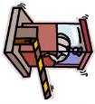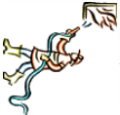**(ARE, IS, AM)**

1. 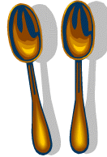I _________
2. He _______
3. She ______
4. You ______
5. 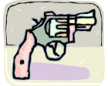We ______ (Guard) (Crying)
6. They ______ (Fire-Fighter) (Spoon) (Cameraman)
7. It ________ (Thinking) (Love) (Gun)
8. j0423854[1]j0423828[1]A Pig _____

(Buy, Elephant, Rich, Candy, Dirty, Robert, Night, Beautiful)

The Opposite of Ugly is ___________

The Opposite of Day is ______________.

The Opposite of Poor is ______________.

The Opposite of Sell is ______________.

The Opposite of Clean is ______________.

(Inside, Next to, Above, Below, Between)

__________ _______________ __________ ___________